DATABASE SYSTEM
Semester Project
Topic: Pharmora (A Pharmacy Database Management System)
by
Tooba Khan (F2024332095), Shifa Ali (F2024332094), Amna (F2024332006)
D1
Submitted to: Mam Noreen Ashraf
Date: 01/06/2026



DEPAETMENT OF ARTIFICAL INTELLIGENCE
Pharmora (A Pharmacy Database Management System)

Problem Statement:
Pharmora is a multi-branch pharmacy management system designed to manage medicines, inventory, suppliers, patients, sales, and purchase orders efficiently. The system helps pharmacy branches maintain medicine stock, track sales records, manage suppliers, and ensure smooth pharmacy operations using a relational database system.

Understanding:
The Pharmora Pharmacy Management System belongs to the healthcare and retail pharmacy domain. A pharmacy manages medicines, suppliers, customers, inventory, and sales operations on a daily basis. Since pharmacies handle a large amount of medicine stock and customer transactions, maintaining records manually becomes difficult and error-prone.
The main purpose of this system is to create a structured relational database that automates pharmacy operations and improves data management.
The domain includes the following major processes:

1. Medicine Management
The pharmacy stores detailed information about medicines such as medicine name, category, dosage, expiry date, stock quantity, and prescription requirements.
2. Supplier Management
Suppliers provide medicines to the pharmacy branches. The system stores supplier details including company information, phone numbers, and addresses.
3. Inventory Management
Each pharmacy branch maintains its own inventory. The inventory module tracks available stock, reorder levels, and stock updates for medicines.

4. Purchase Management
Branches place purchase orders to suppliers when stock becomes low. Purchase orders and their details help manage medicine purchasing and delivery tracking.
5. Patient and Sales Management
Patients purchase medicines from pharmacy branches. The system records patient details, sales records, payment methods, and billing information.
6. Branch Management
The system supports multiple pharmacy branches located in different cities. Each branch manages its own inventory and sales operations independently.

The database design ensures proper relationships among all entities and maintains referential integrity through foreign keys and constraints.

Modules | Purposes
Medicine Management | Store medicine details
Inventory Management | Track stock branch-wise
Supplier Management | Manage suppliers
Patient Management | Store customer records
Sales Management | Handle medicine sales
Branch Management | Manage pharmacy branches
Purchase Management | Handle medicine purchasing

Main Entities:
• Category
• Medicine
• Supplier
• Inventory
• Pharmacy Branch
• Patient
• Purchase Order
• Purchase Order Details
• Sales Record
• Sales Details

Relationships Between Entities
- Category categorizes Medicine
- Supplier supplies Medicine
- Medicine is stored in Inventory
- Pharmacy Branch manages Inventory
- Supplier receives Purchase Orders
- Pharmacy Branch places Purchase Orders
- Purchase Order contains Purchase Order Details
- Medicine is ordered in Purchase Order Details
- Patient purchases through Sales Record
- Pharmacy Branch generates Sales Record
- Sales Record contains Sales Details
- Medicine is sold in Sales Details
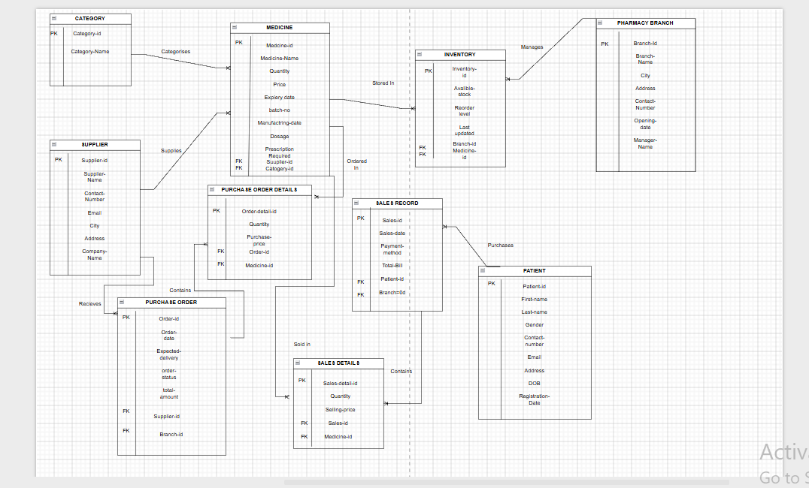
ER Diagram:

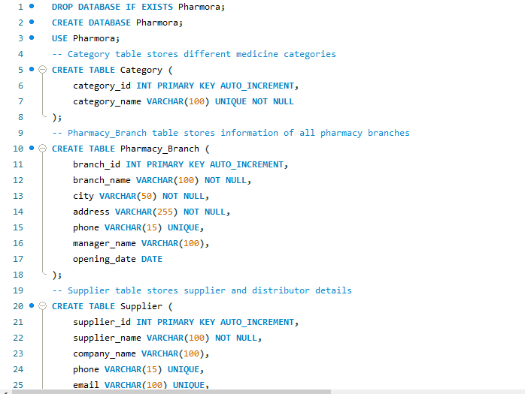
SQL Code:
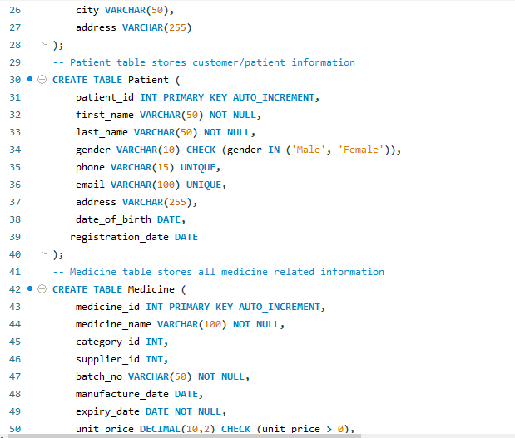

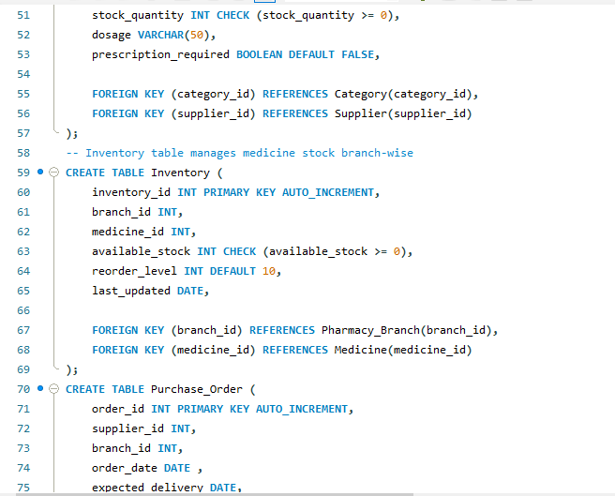

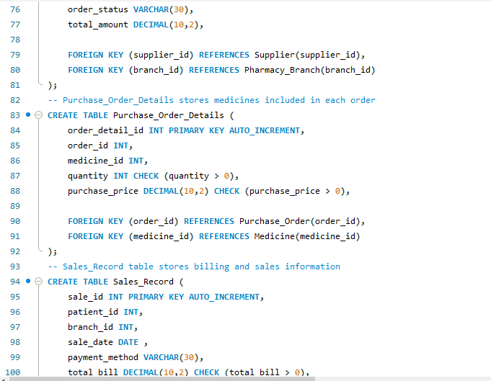

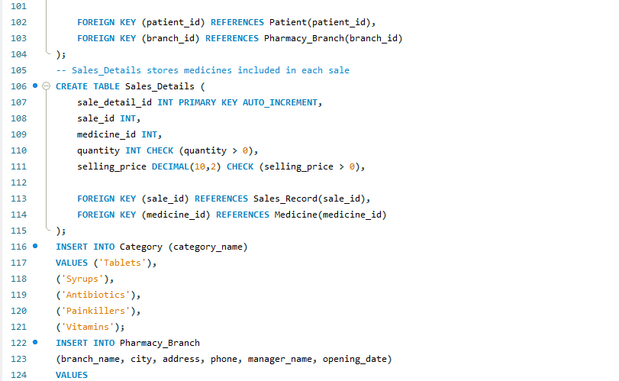
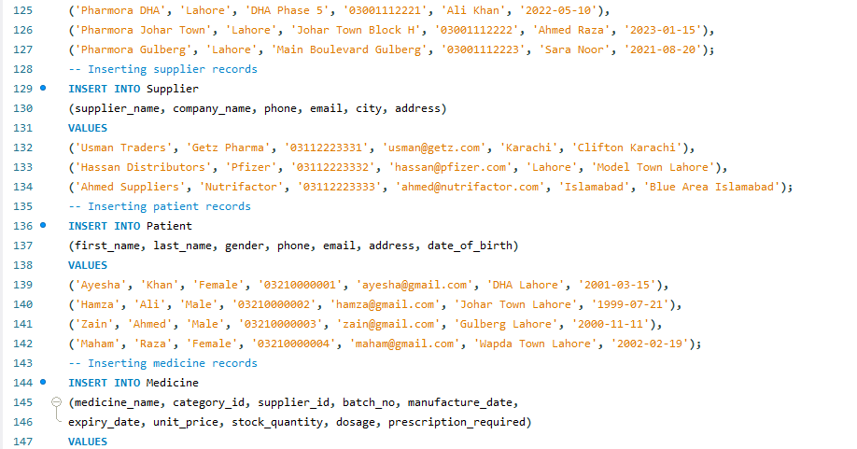

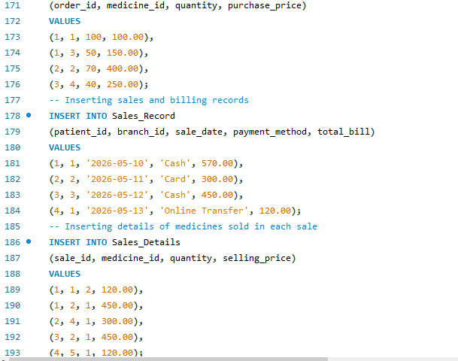
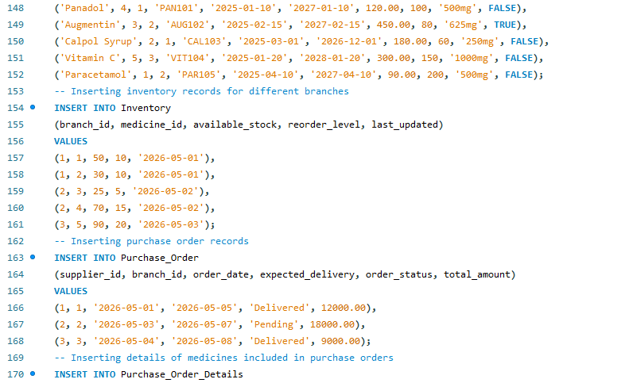

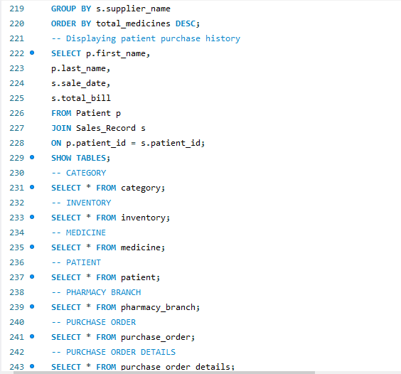
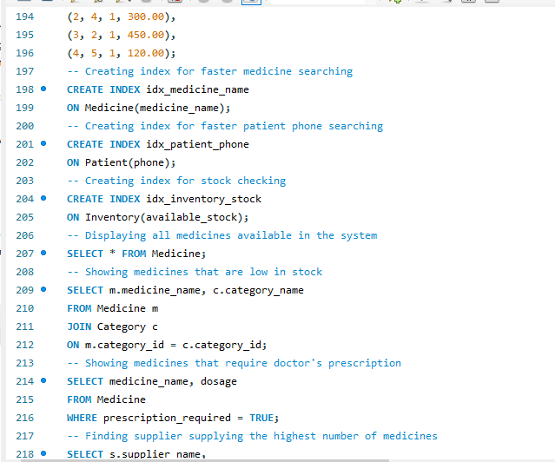



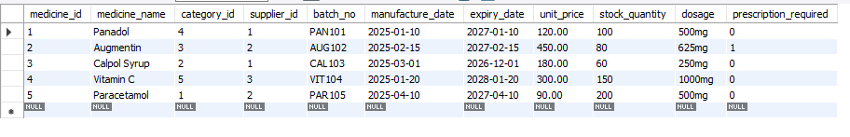
QUERIES RESULT:

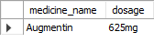
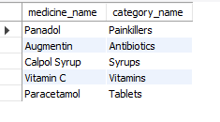

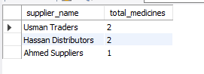
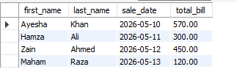

ENTITIES TABLE:
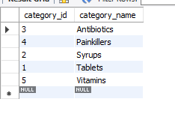
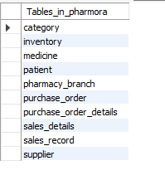
Total table Category table

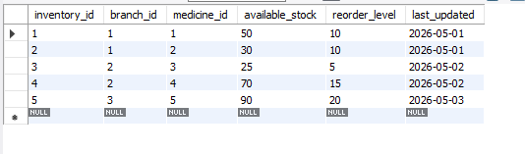
Inventory table

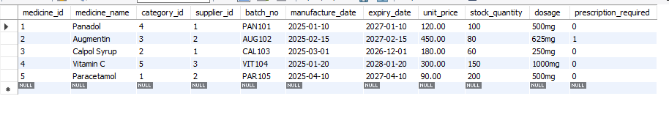
Medicine table
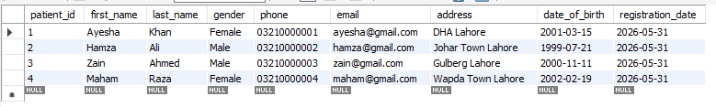
Patient table
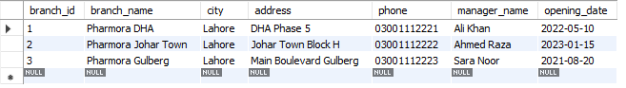
Pharmacy branch table

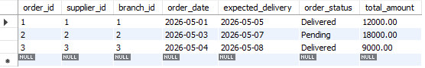
Purchase order table

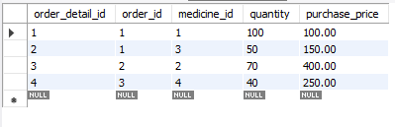
Purchase order details table

Sales details table
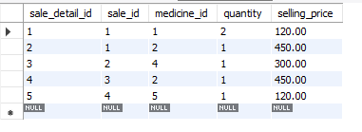

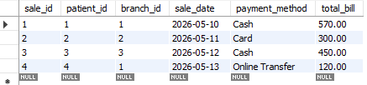
Sales record table

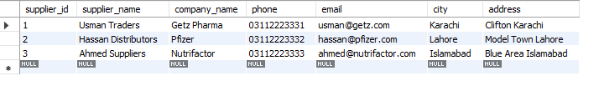
Supplier

